ORCHID INTERNATIONAL COLLEGE
Bijayachowk, Gaushala-9, Kathmandu
Full Marks: 60
Time: 3 Hrs
SET A
Full Marks: 60
Time: 3 hour
Pre Board Examination – 2079

Bachelor Level / First Year/ First Semester/ Science
Computer Science and Information Technology (CSC.111)
(Digital Logic)
Candidates are required to give their answer in their own words as far as practicable.
Group "A"
Attempt Any Two Questions: [2×10 = 20]
- Differentiate between synchronous and asynchronous counter. Explain the working principle of asynchronous 4-bit down counter.
- Implement the following function F= Σ (1, 2 ,8, 12, 13) using
  - Decoder
  - Multiplexer
  - PLA
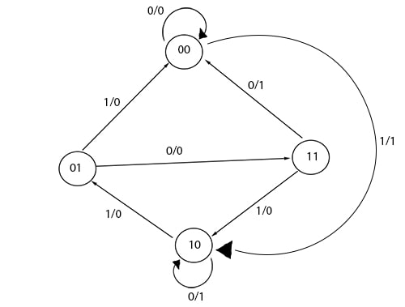
- Design the sequential circuit with respect to the following state diagram using J-K flip flops.

Group "B"
Attempt Any Eight Questions: [8×5 = 40]

- Carry out the following task
  - Perform 1’s complement subtraction 110101 – 100101
  - Represent decimal number 0.125 into its binary form, octal form and hexadecimal form
- Design a combinational circuit with three inputs and one output. The output is 1 when the binary value of the inputs is an odd number.
- Express the Boolean function
  - F = x + yz as product of max-terms.
  - F = A + B’ C in a sum of min terms
- Derive the Boolean expression for sum and carry of full subtractor. Draw its combinational circuit. Implement it using only NAND gates.
- Minimize the Boolean function using K-map
F(A, B, C, D) = Σ(0, 1, 3, 5, 7, 8, 9, 11, 13, 15)
- Explain magnitude comparator.
- What is the difference between a serial and parallel transfer? Explain how to convert serial data to parallel and parallel data to serial. What type of register is needed?
- Explain JK flip flop with necessary logic diagram and truth table.
- Write Short notes on:
  - State Reduction
  - Integrated Circuit
  - ASCII Code
ORCHID INTERNATIONAL COLLEGE
SET B
Bijayachowk, Gaushala-9, Kathmandu
Full Marks: 60
Time: 3 Hrs
Full Marks: 60
Time: 3 hour
Pre Board Examination – 2079

Bachelor Level / First Year/ First Semester/ Science
Computer Science and Information Technology (CSC.111)
(Digital Logic)
Candidates are required to give their answer in their own words as far as practicable.
Group "A"
Attempt Any Two Questions: [2×10 = 20]
- Differentiate between asynchronous and synchronous circuit. Explain the working principle of decade counter.
- Implement the following function F= Σ (1, 2 ,3 ,4, 8) using
  - Decoder
  - Multiplexer
  - PLA
- Design clocked sequential circuit of the following state diagram by using JK flip-flop.
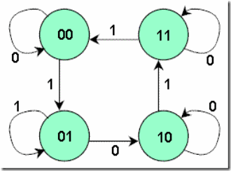

Group "B"
Attempt Any Eight Questions: [8×5 = 40]
- Carry out the following task
  - Perform 1’s complement subtraction 110101 – 100000
  - Represent decimal number 1.125 into its binary form, octal form and hexadecimal form
- Design 4-bit even parity generator.
- Derive the Boolean expression for sum and carry of full adder. Draw its combinational circuit. Implement it using only NAND gates.
- Design a 5 x 32 decoder with four 3 x 8 decoder with enable and one 2 x 4 decoder. Use block diagrams only. Explain its operation.
- Minimize the Boolean function Boolean function using K-map
F(A, B, C, D) = Σ(0, 1, 3, 5, 7, 8, 9, 10, 12, 13, 15)
- Explain Decimal Adder.
- Define register. Explain different types of shift register.
- Explain D flip flop with necessary logic diagram and truth table.
- Write Short notes on:
  - CMOS
  - Triggering Methods
  - EBCDIC

